VIJAYA HOSPITA L

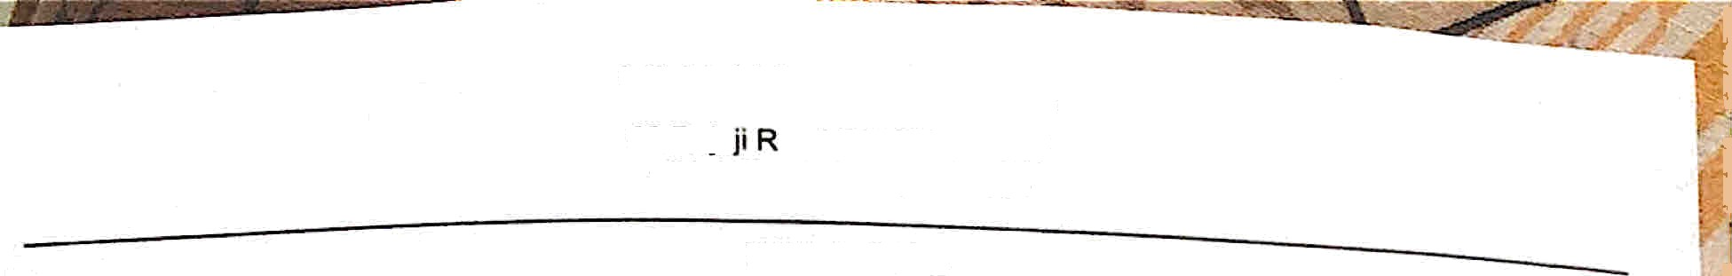

# 63,Raja oad.SALEM-636007

+91 427-4550041 1 7964364

MRN

Pati ent Name

*. y 2* 15 64 3

. Mr s. AMR ITHA

FINAL BILL

Blll No Blll Date

: I P 22 O s1 s <

. 2 6/ 08/20 2 2 06 21 P f.

*Gende i I* Age : 26Y/F

co ntac t No : 81 480 1 5090

Address WÜO• HARIKR ISHNAN

IP No

AdIT\is sio n Tim e Dischar ge Time

’ 8200497

. 25/08/2022

10.52

AFJ

4,SELVARAJ STREET,GANAPATHIPURAM,

CHROMEPET, CHENNAI, CHENNAI

Co nsultar\t t DF. NARMADA MD OG

Ward/Be d

: 26/ 08/2022 06:16 P f4

: SECON D FLOOR / 16 1



Unlt R ate

A mount(Rs)

1500.00

|  |  |
| --- | --- |
| Dese rlptlon | Da te |
| CARDIO TOCOGRAPH | 26/08/22 |
| BABY OXYGEN+WARMER | 26/08/22 |
| INJ.ADMINISTRATION FEE | 26/08/22 |
| NURSING CHARGE | 26/08/22 |
| VISITING CHARGE | 26/08/22 |
| ROOM RENT | 26/08/22 |

1800.0 0

# t 500 00

1 500.00

18 00. 00

500•00 2

500.00

# 150o oo

1 ooo . oo

PAED VISIT IN WARD -Dr.S.RAJENDRAN m.d.(paed) 26/08/22 LABOUR ROOM CHARGES 26/08/22 LABOUR NATURAL —Dr.NARMADA MD OG 26/08/22

Transactio ns

3 i soo. oo

1000.00 2 2000.00

|  |  |  |  |
| --- | --- | --- | --- |
| 400.00 | 1 |  | 4 00.00 |
| 8500.00 | 1 |  | 8500.00 |
| 21000.0 | 1 | 699.30 | Z0300.07 |

|  |  |  |  |  |
| --- | --- | --- | --- | --- |
| Receipt No | D aI e | Descriptio n | Mod e | alue (Rs.) |
| R2200855 | 25/08/22 11:46 AM | Advance | Cash | 20000.00 |
| R2200865 | 26/08/22 06:21 PM | Receipt | Cash | 18500.00 |
|  |  |  | Total | 38500.00 |



# (Rupees thirty eight thousand live hundred Only)

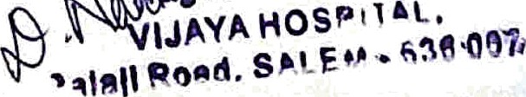

Prepared By : sujatha Conlirmed By : sujatha

For VIJAYA HOSPITAL

on 26/08/22 06:20 PM

on 26/08/22 06:2t PM

*Amount Pard: Balance*

O : 63 ^ 1 •

38500.00

0.00

Bill Total : Round ofl: Net Bill:

38500.07

# —0.07

3ü50 0.08